**Deliverable III**

Alex Paulson, Alex Upton, Bryce Bowser

CSCI 413

**User Guide**

*Bracket Manager*

By: Alex Paulson, Alex Upton and Bryce Browser

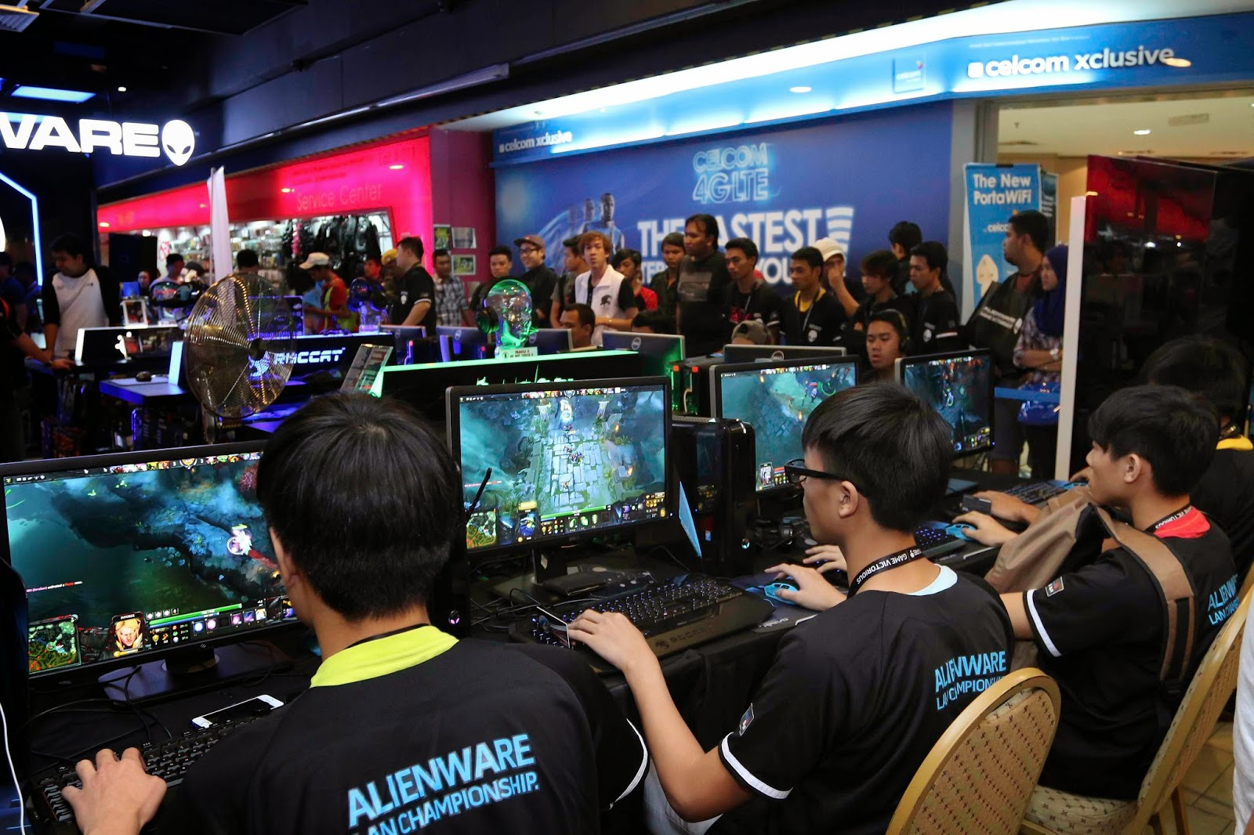

1. Open the application

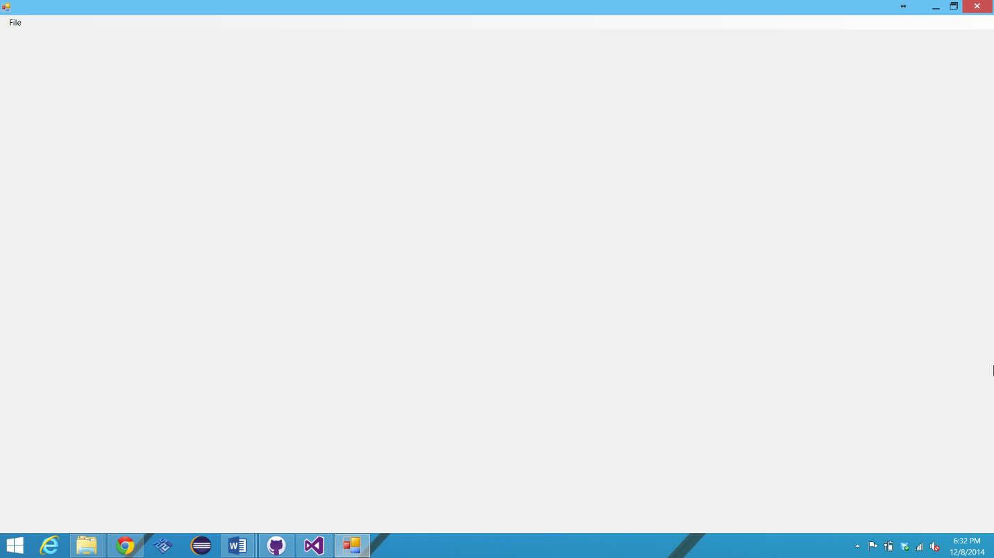

s

1. Select “File”

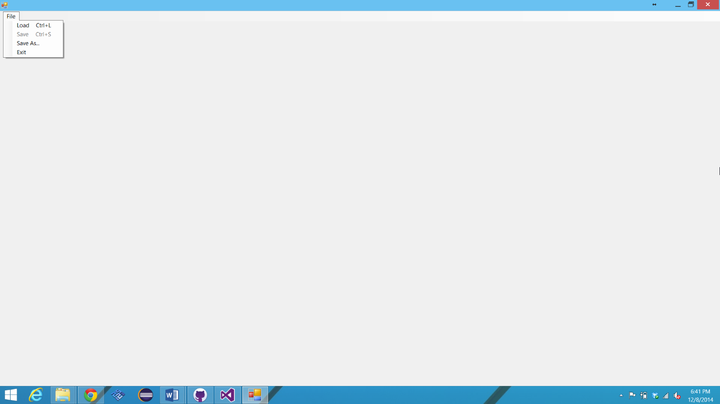

1. Click “Load”

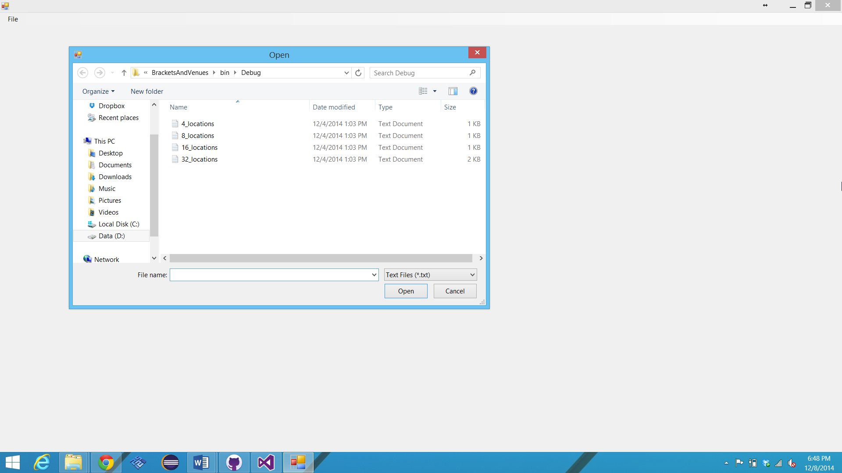

1. Select team file (of appropriate syntax)

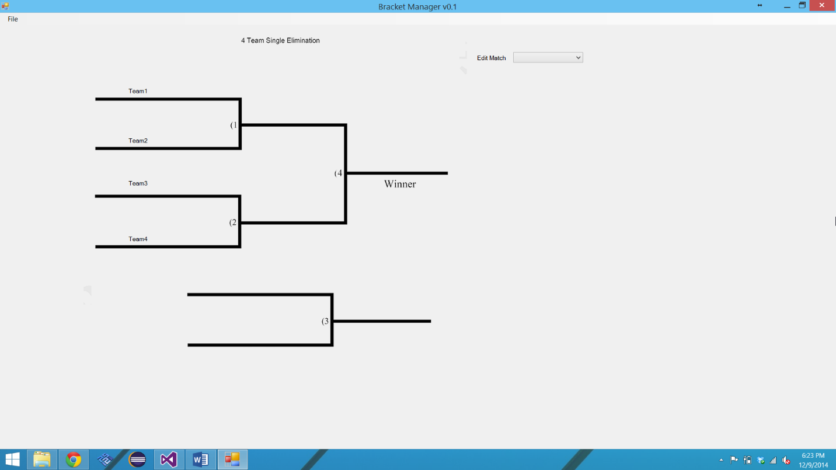

1. Select match # and winner of said match

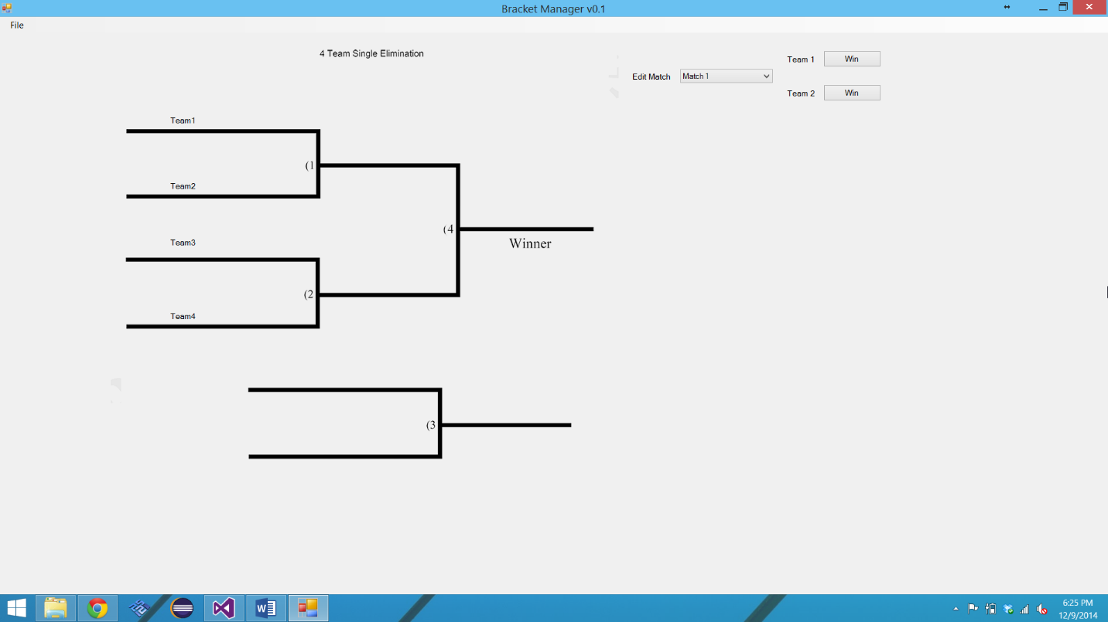

**How to Run**

*Pre-compiled*

1. Make sure you have a team .txt file ready along with the .exe
2. Run the .exe and load the .txt file

Test suite:

* The test suite is simply pre-provided .txt files made by us, which you may choose to use.

Testing

case 4: positionPath = Environment.CurrentDirectory + "\\4_locations.txt"; break;

case 8: positionPath = Environment.CurrentDirectory + "\\8_locations.txt"; break;

case 16: positionPath = Environment.CurrentDirectory + "\\16_locations.txt"; break;

case 32: positionPath = Environment.CurrentDirectory + "\\32_locations.txt"; break;

default: MessageBox.Show("Error loading locations.", "Uh - oh!"); return;

case 4: pictureBox1.ImageLocation = Environment.CurrentDirectory + "\\4_team_bracket.png"; break;

case 8: pictureBox1.ImageLocation = Environment.CurrentDirectory + "\\8_team_bracket.png"; break;

case 16: pictureBox1.ImageLocation = Environment.CurrentDirectory + "\\16_team_bracket.png"; break;

case 32: pictureBox1.ImageLocation = Environment.CurrentDirectory + "\\32_team_bracket.png"; break;

default: MessageBox.Show("Error loading bracket.", "Uh - oh!"); return;

We unit tested the code shown above (the only part that is unit testable as it’s the only one with possible questionable input) with purposefully sabotaged .txt files for locations and team size. The program successfully navigated the incorrect input by either ignoring extra code or rejecting the load and resetting the program for new input.

Ex test:

Team1,3,0

Team2,2,0

Team3,1,0

Team4,6,0

Team5,7,0

**Features implemented**

We successfully implemented the following features:

* Flexible bracket size
* Functioning bracket movement
* Placement by seeding
* Clear and easy functionality through simplicity

Future (not completed) features:

* ASP.NET web front (not seen as a necessary need, could be a possible feature in the future)
* Room manager (would be next logical step for our plan with more time)

**Meeting Schedule**

9/7/14 – Get together, work on requirements and finalize Deliverable I. **ATTENDED. (45 MINS)**

9/14/14 – Prepare UML Diagram and design. **ATTENDED. (90 MINS)**

9/18/14 – Craft game plan for project/order of importance. **ATTENDED. (60 MINS)**

9/24/14 – Miscellaneous work, SQL database start. **ATTENDED. (90 MINS)**

9/30/14 – Work on Deliverable II and see where everyone is at with their duties. **ATTENDED. (30 MINS)**

10/11/14 – Work on Deliverable II again. **ADDED AND ATTENDED. (45 MINS)**

10/13/14 – Finalize Deliverable II. **ATTENDED. (30 MINS)**

10/14/14 – 11/30/14 – Work on code and shift in project ideas/goals

12/1/14 – Towards final code haul **ATTENDED. (120 MINS)**

12/2/14 – Continue final coding **ATTENDED. (180 MINS)**

12/8/14 – Finalize code and presentation **ATTENDED. (120 MINS)**